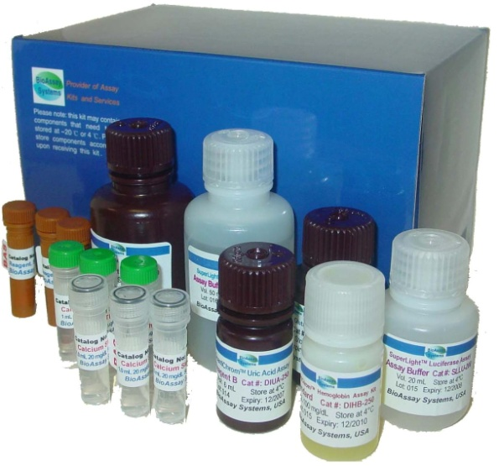
GENTAUR BioAssays System: Solution Pour la Recherche et la Découverte de nouvelles molécules

Réf. | Nom du produit | Nombre d’unités | Prix
Cytotoxicity and Cell Proliferation Assays
CQBL-05K | CellQuanti-Blue™ Cell Viability Assay Kits | 5,000 | € 143
CQBL-10K | CellQuanti-Blue™ Cell Viability Assay Kits | 10,000 | € 236
CQMT-500 | CellQuanti-MTT™ Cell Viability Assay Kits | 500 | € 122
CQMT-01K | CellQuanti-MTT™ Cell Viability Assay Kits | 1,000 | € 174
CTTX-050 | Cytotoxicity Control Reagent (Saponin) | 50mg | € 80
ECTX-200 | EnzyLight™ Cytotoxicity Assay Kit | 200 | € 164
BioAssay Kits
DACE-100 | QuantiChrom™ Acetylcholinesterase Assay Kit | 100 | € 320
DALP-250 | QuantiChrom™ Alkaline Phosphatase Assay Kit | 250 | € 247
DAMY-100 | QuantiChrom™ α-Amylase Assay Kit | 100 | € 340
DARG-200 | QuantiChrom™ Arginase Assay Kit | 200 | € 299
DATG-200 | QuantiChrom™ ATPase/GTPase Assay Kit | 200 | € 299  Cell Proliferation and Cytotoxicity Assay Kits  CellQuanti-Blue™ et CellQuanti-MTT™:  Colorimétrique, non-radioactif, facile et haute sensibilité pour les proliférations cellulaires, cytotoxicité, facteurs de croissance, cytokines, nutriments, antibiotiques et agents anti-cancer.  Bioassay Kits  QuantiChrom™ Assay Kits: Kits Quantitatifs chimiques et fluorimétrique pour la découverte de molécules, pharmacologie et déterminations directement dans des échantillons biologiques complexes, la nourriture, les boissons…  EnzyChrom™ Assay Kits: Kits enzymatiques quantitatifs pour la découverte de molécule, pharmacologie et determinations directes dans des échantillons biologiques complexes, la nourriture, les boissons…  Saccharide Removal kit: Enlève de manière quantitative les saccharides (glucose, sucrose) qui interfèrent dans un échantillon. Doit être utilisé avec QuantiChrom™ Ethanol Assay Kit DIET-500.  Phosphatase Assay Kits  pNPP Phosphatase Assay Kits: simple, efficace et d’une haute sensibilité pour l’activité des phosphatases, la cinétique des enzymes et pour les inhibiteurs de phosphatase.  Malachite Green Phosphate Assay Kits: rapide, simple, efficace et d’une haute sensibilité pour la phosphatase, phospholipase, les inhibiteurs d’enzymes…  Bioluminescence Assay Kits  SuperLight™ Luciferase Reporter Gene Assay Kits: rapide, simple et d’une haute sensibilité, pour la régulation des gènes et pour les modulateurs de l’expression des gènes. Idéalement formulé pour les récepteurs impliqués dans la régulation des gènes comme Gs- et Gq GPCRs.  EnzyLight™ Bioluminescence kits: Détermination Rapide, quantitatif, bioluminescente des concentrations de cellules d’ATP concentration et du ration ADP/ATP.
DIAG-250 | QuantiChrom™ BCG Albumin Assay Kit | 250 | € 247
DIAP-250 | QuantiChrom™ BCP Albumin Assay Kit | 250 | € 247
DIBR-180 | QuantiChrom™ Bilirubin Assay Kit | 180 | € 236
DICA-500 | QuantiChrom™ Calcium Assay Kit | 500 | € 268
DICL-250 | QuantiChrom™ Chloride Assay Kit | 250 | € 216
DICT-500 | QuantiChrom™ Creatinine Assay Kit | 500 | € 278
DICU-250 | QuantiChrom™ Copper Assay Kit | 250 | € 382
DIET-500 | QuantiChrom™ Ethanol Assay Kit | 500 | € 361
DSRK-500 | Saccharide Removal Kit | 500 | € 122
DIFE-250 | QuantiChrom™ Iron Assay Kit | 250 | € 288
DIGL-100 | QuantiChrom™ Glucose Assay Kit | 100 | € 216
DIGL-200 | QuantiChrom™ Glucose Assay Kit | 200 | € 257
DIGT-250 | QuantiChrom™ Glutathione Assay Kit | 250 | € 299
DIHB-250 | QuantiChrom™ Hemoglobin Assay Kit | 250 | € 257
DIHM-250 | QuantiChrom™ Heme Assay Kit | 250 | € 247
DIMG-250 | QuantiChrom™ Magnesium Assay Kit | 250 | € 278
DINO-250 | QuantiChrom™ Nitric Oxide Assay Kit | 250 | € 288
DIOX-250 | QuantiChrom™ Peroxide Assay Kit | 250 | € 247
DIPI-500 | QuantiChrom™ Phosphate Assay Kit | 500 | € 257
DIUA-250 | QuantiChrom™ Uric Acid Assay Kit | 250 | € 299
DIUR-500 | QuantiChrom™ Urea Assay Kit | 500 | € 278
DIZN-250 | QuantiChrom™ ZincAssay Kit | 250 | € 372
DLDH-100 | QuantiChrom™ Lactate Dehydrogenase Kit | 100 | € 236
DLPS-100 | QuantiChrom™ Lipase Assay Kit | 100 | € 340
DSFT-200 | QuantiChrom™ Sulfate Assay Kit | 200 | € 268
QCPR-500 | QuantiChrom™ Protein Assay Kit | 500 | € 153
QFDN-250 | QuantiChrom™ DNA Assay Kit | 250 | € 247
ECCH-100 | EnzyChrom™ Cholesterol Assay Kit | 100 | € 299
ECET-100 | EnzyChrom™ Ethanol Assay Kit | 100 | € 278
ECLC-100 | EnzyChrom™ Lactate Assay Kit | 100 | € 299
ECND-100 | EnzyChrom™ NAD/NADH Assay Kit | 100 | € 320
ECNP-100 | EnzyChrom™ NADP/NADPH Assay Kit | 100 | € 320
ECPK-100 | EnzyChrom™ Creatine Kinase Assay Kit | 100 | € 372
Phosphatase Assay Kits
POMG-25H | Malachite Green Phosphate Assay Kit | 2,500 | € 143
POPB-500 | PiBlue™ Phosphate Assay Kit | 500 | € 153
POPN-500 | pNPP Phosphatase Assay Kit | 500 | € 143
POPN-01K | pNPP Phosphatase Assay Kit | 1,000 | € 226
Bioluminescence Assay Kits
SLLU-200 | SuperLight™ Luciferase Reporter Gene Assay Kit | 200 | € 122
SLLU-500 | SuperLight™ Luciferase Reporter Gene Assay Kit | 500 | € 226
SLLU-01K | SuperLight™ Luciferase Reporter Gene Assay Kit | 1,000 | € 392
ELDT-100 | EnzyLight™ ADP/ATP Ratio Assay Kit | 100 | € 257
EATP-100 | EnzyLight™ ATP Assay Kit | 100 | € 247

